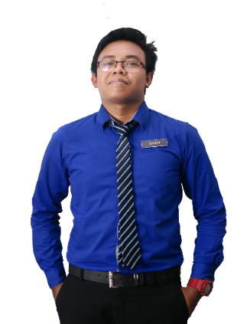

Head of Islamic Department

Sekolah Men. Agama Al-Falah.

Phone: +6019-9136607

**MISS ROHAFESVAL BINTI ABDUL WAHAB**

Sept 2016-Nov 2016

Feb 2017 - Nov 2019

**SMITYT KEMAMAN, YAYASAN TERENGGANU**

**EXPERIENCE**

**FROGASIA SDN BHD (A TYL COMPANY)**

Customer Advocate

Tasmik Teacher

Human Resource Department

Frog Asia Sdn. Bhd.

Phone: +6016-6025612

**MISS REBECA ANNE**

**LANGUAGES**

**ENGLISH**

**MICROSOFT EXCEL**

**MICROSOFT WORD**

**MICROSOFT POWER POINT**

**PROFESSIONAL SKILLS**

**MALAY**

Secondary School Teacher

**SEKOLAH KEB. KIJAL**

**SEKOLAH MEN. AGAMA AL-FALAH**

Primary School Teacher

**REFERENCES**

Mac 2013 - Apr 2013

Apr 2013 - Sept 2014

**RAHEMALIZAL**

**SEKOLAH MEN. AGAMA AL-FALAH**

* Program Planning Student Assembly (PSA) 2011
* Pengawas Pusat Sumber Sesi 2008 SMK Sultan Ismail
* Pencapaian Terbaik Mata Pelajaran Sejarah Percubaan STPM 2008
* Member of Malaysian Institute of Planners 2009

RACE: MALAY

DATE OF BIRTH: 02 FEBRUARY 1989

MARITAL STATUS: MARRIED

GENDER: FEMALE

**E-MAIL:**

Penilaian Menengah Rendah (PMR)

Dedicated and self-motivated individual seeking for a challenging working opportunity in an organization to utilize my personal capability and creativity that would allow me to develop my skills while contributing to the organizational goals.

2002 - 2004

2007 - 2008

2005 - 2006

2009 - 2012

* Seminar Kaedah Mentadbir Hati & Kaedah Menghafaz Untuk Pembimbing Al-Quran SM Imtiaz Yayasan Terengganu 2015
* Bengkel Penjenamaan USM
* Wacana Ilmu II Anjuran Persatuan Mahasiswa Islam USM
* Pimpin Siswa Siri 4 USM
* Forum Wacana Intelek: Agama No. 1 Akademik Bukan No. 2

Sijil Tinggi Persekolahan Malaysia (STPM)

**SEKOLAH MEN. KEB. SULTAN ISMAIL**

**SEKOLAH MEN. AGAMA AL-FALAH**

Sijil Pelajaran Malaysia (SPM)

Bachelor of Science (Urban and Regional Planning)

**UNIVERSITI SAINS MALAYSIA (USM)**

resumecreative@yahoo.com

**RAHEMALIZAL BINTI ABDUL WAHAB**

**OBJECTIVE**

**ACHIEVEMENT / PARTICIPATION**

**EDUCATION**

**CONTACT**

Block 3-4-5, Vista Angkasa Apartment, Jalan Kerinchi, 59200 Kuala Lumpur

**ADDRESS:**

+6013-2805916

**PHONE:**